

ChronoTrack Systems, Inc.

111 East Diamond Avenue

Evansville, Indiana 47711

U.S.A.

812-423-7800 Main

812-759-7877 Support

812-423-7801 Fax

www.chronotrack.com

**Volunteer Bib Assignment Guide**

# Introduction

Please read the instructions below carefully. This guide will walk you through the processes assigning bib numbers and answer any common questions about on-site kiosks that might arise.  
If there is a question you cannot find an answer for in this guide, seek help from the Race Director or Timer. If they are not available and the issue is critical, please contact ChronoTrack Support at [**esupport@chronotrack.com**](mailto:esupport@chronotrack.com) OR **(812) 759-7877**

# Initial Kiosk & Link Setup

1. If it has not already been plugged in, plug in the barcode scanner via USB for each kiosk.  
   **Note: The Chromebook model and scanner/reader orientation may be different than pictured.**
2. Plug the kiosks into a power outlet if available and accessible (fully charged the kiosks should last 5-6 hours on battery power).
3. 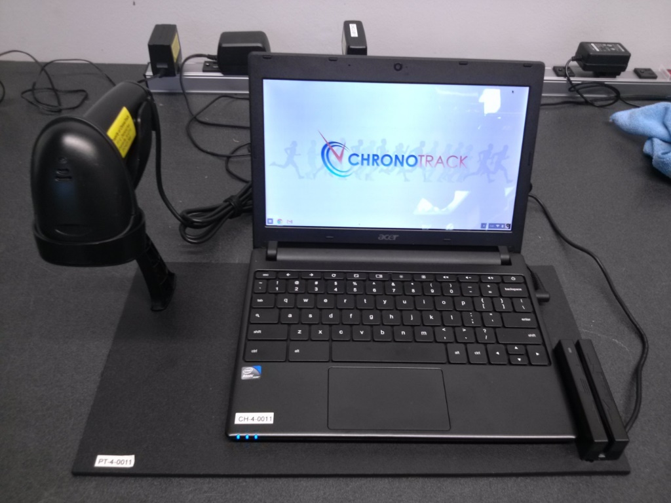If the laptop screen is not open, lift the screen. The laptop should power on automatically. If it does not, press the Power button located at the top right corner of the keyboard.
4. Once the laptop is powered on, you should have the Timer or Race Director for the event put in the password.
5. 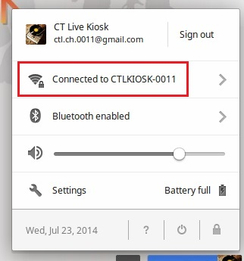When the computer logs in, check the WiFi connection in the lower right hand corner. The icon resembles a funnel or fan shape. If the icon is solid white, the WiFi connection is active. If it is not solid or partially white, you may need to seek assistance.
6. Click on the icon to make sure it says “Connected to CT-KIOSK-XXXX” (Number of the Kiosk Set).
7. Google Chrome should have already launched. If it did not, click on the Google Chrome logo (first logo on the lower left hand corner).
8. 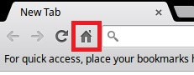Click on the home page icon on the top left portion of the browser.

The on-site page should now appear as shown below. If it does not, please seek assistance from the Timer or Race Director.

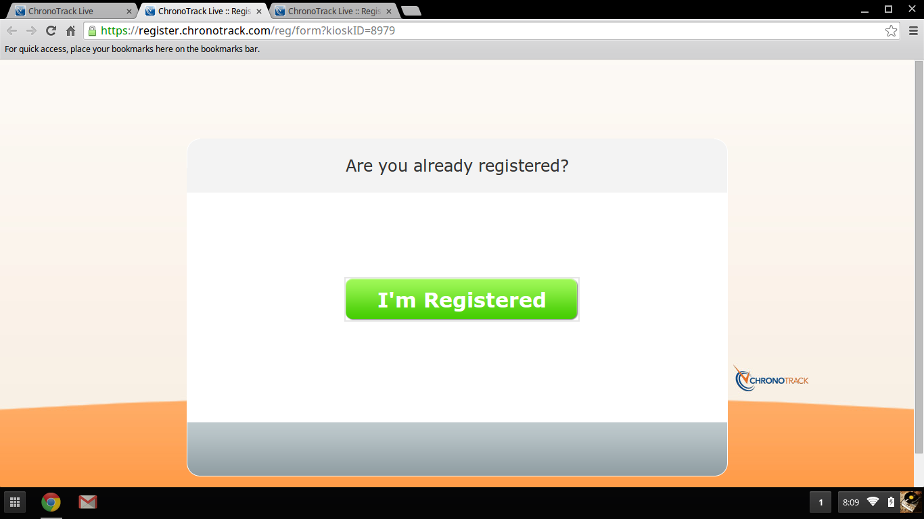

If necessary, repeat the steps above for each Kiosk until all are set up and ready.

# Bib Assignment

A few things to keep in mind:

* If at any point the kiosk computer becomes unresponsive, try re-loading the web page by pressing the Ctrl and R at the same time.
* If you are not on the correct check-in webpage anymore you can click on the home page icon on the top left portion of the browser. This *should* return you to the correct page. If it does not, seek assistance from the Race Director or Timer.

## Assigning Bibs

1. When assigning bibs to pre-registered participants, use the **I'm Registered** button.
2. 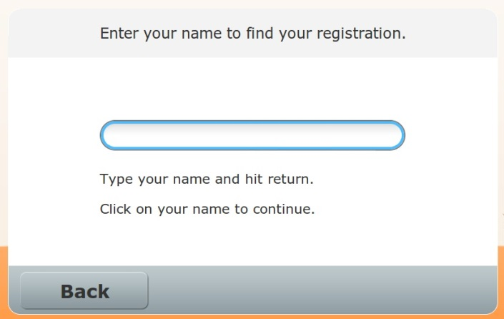Type in the participant's name and press enter to search.

* You may search by first name, last name, or both first and last name.
* If you are unable to find someone, you can change up the way you are searching (if you looked by last name, try first and last, or first name only).
* You may also search by partial name if someone has a difficult name such as 'Wladyslaw Szpilman'. In this type of scenario, try searching for 'Wlad' or ‘Szp’.
* 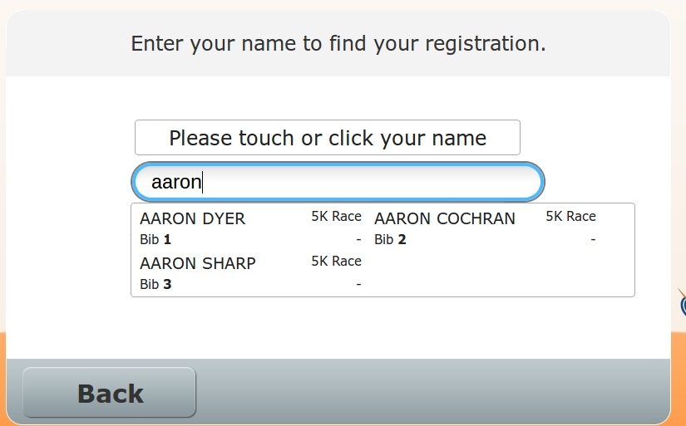If there is more than one match to the name a list will pop up. Click on the name you're looking for from the list and assign the bib number.

**Note: The list will only display the top 10-12 names that match the name you entered. So if you type a common name such as 'John', the John you are looking for may not be displayed. You will need to type in a portion of John's last name to narrow the search.**

1. 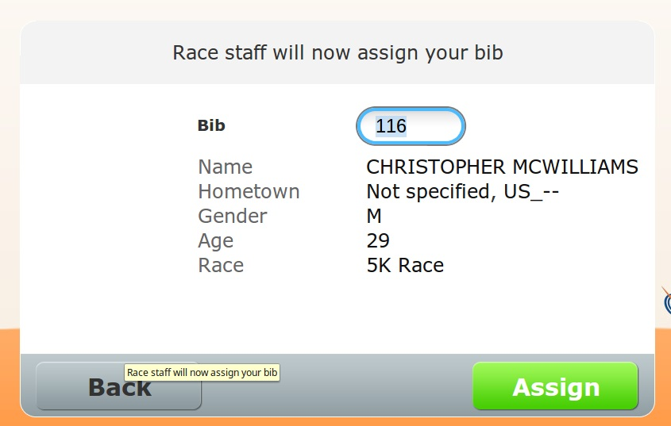If the database finds one match for a search, it will take you directly to the bib assignment screen.
2. Verify that the Athlete’s information is correct.
3. Take the next available bib number from the top of the stack. *Please bear in mind that there may be multiple stacks if there are multiple races or types of entrants in the event.* **Carefully** type the bib number in, **double-check** the number, and click the **Assign** button at the bottom.
   1. You can also use the barcode scanner to auto-fill the bib field. This is very useful for avoiding mistakes when manually entering numbers. If there are no barcodes on the bibs, please use the process above.

# Troubleshooting/FAQ

Please note that the answers to some of these troubleshooting steps are in the guide above. Please read the guide carefully.

* **I can’t find a Pre-Registered Athlete in the ‘I’m Registered’ screen.** 
  + If you cannot find their name by how you searched try just first name or a few letters of their last name or a combination of both.
  + It is also possible that the athlete didn’t complete the pre-registration form. Ask them if they verified that a payment came out of their credit or debit account. You may need to have the Athlete re-register.
  + Sometimes people register via Facebook, and if their Facebook name is not the name they give you (for instance if they don't use their last name on Facebook) or if they registered with a maiden name, you may not be able to find them. Try searching for the first name. If the person still does not appear in the list, seek assistance from the Timer or Race Director.
  + The list will only display the top 10-12 names that match the name you entered. So if it is a common name like 'John', the John you are looking for may not be displayed. You will need to type in a portion of John's last name to narrow the search.
* **Oops! I entered the bib number wrong!** 
  + If you enter a bib number incorrectly, you can re-assign a bib number by pulling that person up again under the **I’m Registered** screen and replacing the number that was mistakenly assigned with the correct one.
* **An Athlete already has a bib number assigned.** 
  + If someone already has a bib number assigned to them it means that they or maybe a friend or family member picked up their bib already. Ask them to check with anyone who might be trying to do them a favor but forgot to let them know. If after checking they insist that no one has picked up their bib, *you should check with the Timer or Race Director before assigning a second bib number.*
* **There’s some weird code or message on the screen…**
  + You can always click the Refresh button or X out of any error message. The worst that can happen is that the Bib number will need to be entered again.

# Tips

* If there are any necessary athlete information changes or additions, please record them on the attached form.
* As you assign the bibs ***write down the athlete's name on the back of the bib***. This will help avoid confusion if they have bibs for multiple family members or set their number down next to a friend's at a later point.
* It is often helpful to write down an Athlete’s shirt size on the back of the bib if their shirts are being given out at a separate pickup table or different time (if at all).
* As people are handed their bibs, it is a good practice to always remind them their bib has their timing chip on it (if they are in a timed race) and to not bend or fold the chip. It is also good to remind Athletes of the proper position to wear the bib (across the midriff) and convey that an improperly worn bib can affect their timing.

If after reading the above instructions you cannot find an answer to a question, please talk to your Race Director or Timer. If they are unavailable and the issue is extremely urgent, please try **ChronoTrack Support at (812) 759-7877**

